

*Faculty of Engineering and Technology*

*Computer Science Department*

*First Semester, 2022/2023*

*Software Engineering Comp433*

***CrossFit Project***

*Prepared by:*

|  |  |
| --- | --- |
| Students Name | Student Number |
| Ali Maree | 1190502 |
| Sara Ammar | 1191052 |
| Al Ayham Maree | 1191408 |
| Dana Shtaya | 1191868 |

*Instructor: Dr.* [*Samer*](https://ritaj.birzeit.edu/bzu-msgs/type?mttid=104&classid=196326) *Zein*

*Section: 2*

*Date:*

*6-2-2023*

**Contents**

**1.** **Phase -1-** 3

**1.0.** **Introduction** 3

**1.1.** **System Features** 5

**1.2.** **Software development process** 7

**2.** **Phase -2-** 8

**2.0.** **Use Case Diagram** 8

**2.0.0. Use case Diagram description** 9

**2.1.** **Requirements** 14

**3.** **Phase -3-** 20

**3.0.** **Conceptual class diagram** 20

**3.1.** **Sequence diagrams** 21

# **Phase -1-**

## **Introduction**

“**CrossFit**” is a mobile application that would be created for a fitness center provides high-quality fitness and GYM services. The center's trainers, accountants, members, reception unit, manager and owner can all use this system. The primary purpose of our software is to fully control the center operations, memberships, schedules, and provide better services to the members of the center's expanding community.

Our software application is an intelligent system that will solve common problems in all fitness centers. We can promise to finish all customer registration and payment process in less than 2 minutes because we will use easy smart software system with full reports saved in a database. It will lead the center to easy success by increasing the productivity of the center. This software is designed to handle fitness center very efficiently.

With the aid of our contemporary AI system, machine learning strategies, and other cutting-edge technology, this software will prevent the club from experiencing data loss and dispersion, incorrect and time-consuming manual operations, inaccurate and scattered data from several Excel spreadsheets, lower productivity, and security risks. The data base will be used to improve the management of the collected data, develop the center's services and increase its profits.

In essence, our system will have six interconnected gates:

The customer portal aims to offer customers a full range of service options, including the ability to view available memberships, sign up for a new membership, and obtain new promotional memberships, as well as access their nutritional programs, schedule of exercises, communicate with their trainers, receive notifications about their training and nutrition programs and subscription expiration date, share feedback, and make payments.

The trainer portal, which enables them to access their schedule and program (body building, swimming, boxing, etc.) and time plans, view their salary and other financial obligations, create training schedule for members and also nutrition program, and notifying members about their training and nutrition programs, and create challenges for the trainees.

The accounting portal provides help for all monetary issues, revenues, and payment information, this portal enables accountants to track members’ payments, expenses of the center, payroll salaries for employees by accessing current databases and making legal changes to it.

The reception unit portal tends to help the receptionists with verifying the registration of members, notify them about discounts, tracking the memberships, payments, and locker memberships, and manage the payments.

The software is controlled and maintained by the admin portal responsible for manage users and permissions, system backup and managing all branches in the system.

The management portal, which has complete control over database queries which are concerned with reports about members, memberships, financial status, expenses, etc.

## **System Features**

* **Regular training schedules:** Using AI, the program provides the possibility of creating consistent and conflict-free schedules, in an easy way for trainers and clients, as trainers can book available places for classes at the times they want, as well as clients, where they can register for their favorite classes without overlapping appointments.
* **Membership cards and smart door lock:** Our program is integrated with electronic membership cards for the club to manage membership activities and maintain the safety of the club's facilities. Each member will receive a smart membership card that will be used to open the center's door during working hours. So, the card reader is connected to the club's database where it realizes whether the card entered is valid or not. Moreover, the door will not be opened for terminated members, and this card will track important data such as the time and date of entry and departure of the member, the number of times it is used, and other information about the cardholder.
* **Advanced system for measuring room:** by using advanced sensors for taking the height and weight of the members, and store the taken values into the database automatically by referring to the member’s card. Furthermore, the trainers will be able to track the weight of members effectively and flexibly by using database queries.
* **Registration using touch screen:** A touch screen can be placed at the entrance of the center in the registration unit and linked to the database to be used to register membership in the center and view the training schedule. The screen also displays the most prominent programs and offers of the center to encourage visitors and passers to make a membership.
* **Different payment methods supported:** Our system will support three main payment types: cash and checks that will be registered via the accountants monitoring or via visa that can be done through our software and it will be recorded for the accountants.
* **Reminder (Notifications):** Send a notification message to the customer through email or SMS to remind him\her about his\her membership expiration, payments, promotions, daily exercises in advance.
* **Chatbots (AI Implementation):** Intelligently provide customers with answers for questions about services, advice, and any commonly asked questions as well as providing an online chatting option.
* **Customer’s Feedback:** customers can provide their feedback through a reviews page about the center prices, services, trainers, programs, exercise and GYM equipment; leading to create a transparent relation between different customers and the center.
* **A fully responsive software:** supports every operating system.
* **Multi-language support is provided:** Enriching the experience of using this software, members, as well as center’s employees, can choose their preferred language when using this software.
* **Constant enhancement reports based on customers’ orientations:** Making benefit of the data with the help of machine learning to get useful reports for plans such as member distributions among different equipment in the same time, predict the accurate number of available trainers, re-pricing the memberships based on machine learning prediction for the members’ wants and needs in the future.
* **Automated emails sent to the client’s email with all information about membership, schedules, nutrition program, payments, registration:** Having all legal information available to the member at any time, providing members and the center with a secure documented experience.
* **secure system:** Our program provides a high degree of security, as each person in the system has specific restrictions that cannot be violated. In addition to providing high protection for customer data, private information, and payment information.
* **Non-functional related features:** This software provides a flexible and user-friendly interface for each portal, requiring no real training for regular users and no more than two days for the center’s employees to know every detail. Continuous system maintainability and improvement in constant system support.

## **Software development process**

Software for a fitness center may be divided into manageable chunks. This is why we've chosen to take an incremental approach. These components undergo analysis, design, coding, and verification. Implementing software that is so dependent on consumer connection requires taking input continuously.

Building “CrossFit” software requires a process that welcomes change and so an incremental process is considered.

The incremental process seeks to deliver the project without delay and to be prepared for the markets, while also saving time, ensuring that the work is regularly tested, lowering the cost needed to handle the customers' input, and ensuring that the work is frequently tested. By giving customers the ability to keep track of and update the project and implementation process, customers will value their constructive project engagement. Customers are seen favorably by programmers since they allow for discussion and provide for early feedback.

The social work environment is seen as tranquil, reliable, compassionate, and long-lasting. Process control, accountability, and quality are improved by continuous integration and small, doable tasks. Additionally, greater communication and regular input from each iteration lead to better information transmission.

# **Phase -2-**

## **Use Case Diagram**

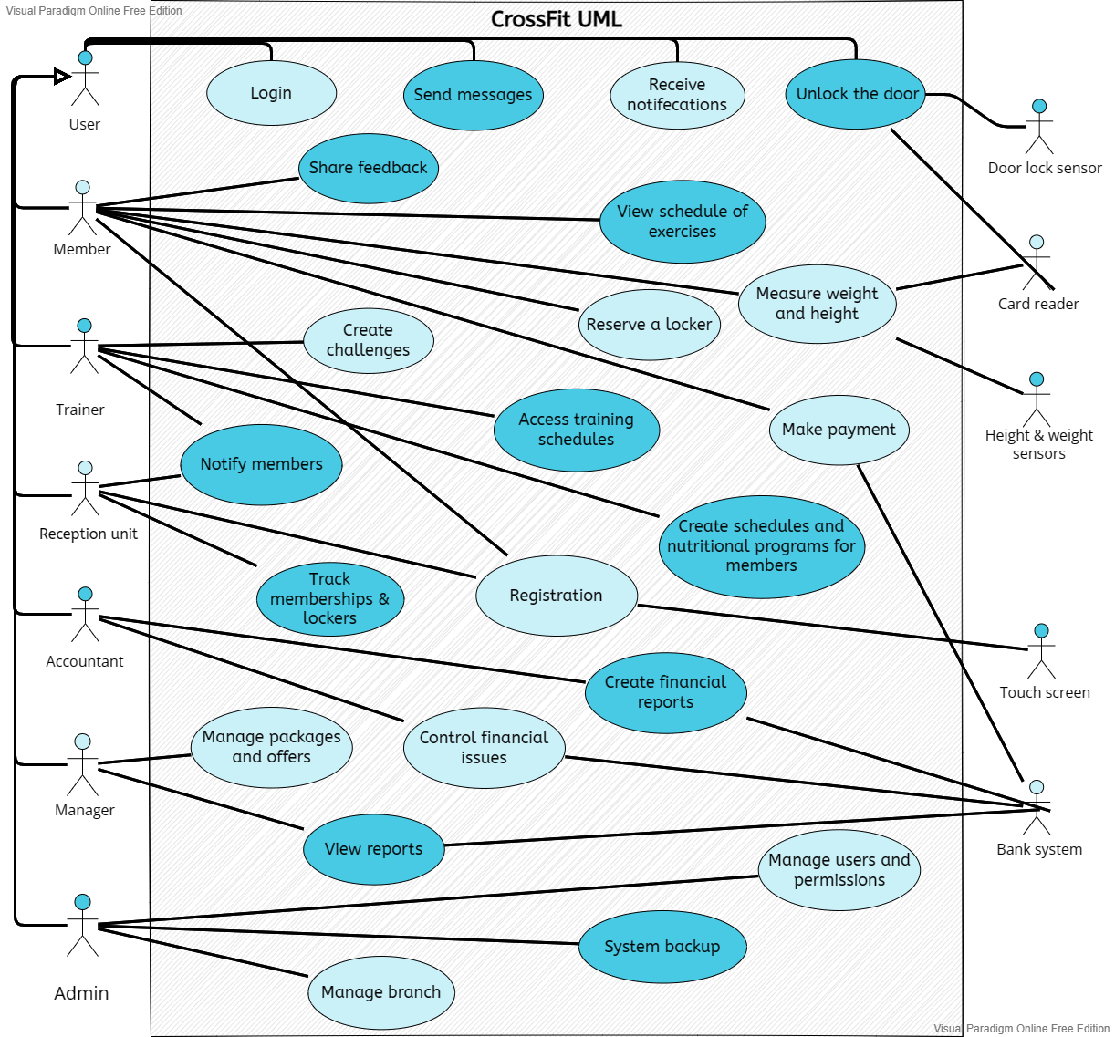

### **2.0.0. Use case Diagram description**

**Actors:**

|  |  |
| --- | --- |
| Actor | Description |
| User | All users of the application whom have the ability to login to the app, send messages between each other, and receive notifications, and unlock the door by the help of the door lock sensor. |
| Member | The client of the GYM who comes for training. He can register for a membership using the mobile app, touch screen, or by the help of reception unit. Also, he pays for his memberships via different methods which will be recorded in the bank system. In addition, he can share feedback, view his schedule of exercises, reserve a locker, and measure his weight and height. |
| Trainer | The employees responsible for providing training. They can access their daily training schedules, create schedules and nutritional programs for members and notify them about their schedules. |
| Reception unit | The employees responsible for receiving and assisting the club's clients. They can register new members upon their request, track memberships and lockers to check the expiration of the membership, and notify members about the expiration of their memberships and lockers. |
| Accountant | The employee responsible for all financial matters in the club and create financial reports about the bank system which are required by the manager, and control the financial issues such as the payment methods. |
| Manager | Is the manager responsible for managing all the club's affairs and who can view all reports created by the accountant such as: the revenues and expenses, and salaries of all employees, and reports from reception unit like the number of members. |
| Admin | Is the person responsible for all technical matters in the application. |
| Door lock sensor | A sensor located on the club's gates, only allowing the entry of persons allowed to enter the club. |
| Height & weight sensor | A sensor located on the club's dedicated equipment to measure the trainee's height and weight. |
| Card reader | Is a card reader located at the club's gates and on the height and weight measuring devices to identify the trainee's identity. |
| Touch screen | A screen located in the reception hall to help customers for their registration. |
| Bank system | The system records all financial issues of the GYM such as membership payments and salaries. |

**Use cases:**

|  |  |
| --- | --- |
| Use case | Description |
| Registration | Members have the ability to register using the mobile app or the touch screen by entering all required data. However, the reception unit can register a new member upon his/her request using the desktop app or the touch screen. |
| Login | After a successful registration, all users of the system shall login to their accounts depending on their role in the GYM. |
| Send messages | All users should be able to communicate with each other within the app. |
| Receive notifications | All users should receive notifications from messages, reports, or advertisements. In addition, the member should be notified about his/her schedule and program from his/her trainer and his/her membership from the reception unit. |
| Unlock the door | All users shall unlock the door using their smart card which is read by the card reader. However, the card reader shall unlock the door using the door lock sensor. |
| Share feedback | Club members should post feedback and their own opinions about the club, management, trainers, and courses offered. |
| View schedule of exercises | The members shall view their schedule of exercises which is assigned by their trainer. |
| Measure weight and height | Measure weight and height: the member should measure his/her weight and height by using measuring room which is equipped with weight and height sensors. The measurements are stored using the card reader which enables the trainer access them. |
| Reserve a locker | The member should be able to reserve a locker through the app and the cost of the locker shall be added to the membership. |
| Make payment | A club member should pay for subscriptions through the application, as it is directly connected to the banking system. |
| Create challenges | The trainer should offer challenges to the members in order to encourage them to do and adhere to the sports and health systems. |
| Access training schedules | Trainers shall be able to access their training schedules to inform them about their daily activities and which members to train. |
| Create schedules and nutritional programs for members | According to the measurements that the members have, the trainers should create schedules and nutritional programs for members; depending on the measurement results, to meet member needs. |
| Notify member | Trainers should be able to notify members about their exercises schedule and nutrition program. As well as the reception unit shall notify members about discounts and expiration of their memberships. |
| Track membership & lockers | The reception unit shall keep track of the membership of each member of the club, and in the event that the subscription ends, inform it of this, as well as for the lockers. |
| Create financial report | The accountant should prepare daily or monthly or weekly reports on all financial matters related to the club and put warnings in them in case of problems and submit them to the manager. |
| Control financial issues | Accountants are responsible for monitoring financial controls, such as audits, risk assessments and analysis of all operational scenarios. Moreover, one of their most important responsibilities is the distribution of salaries, accrued annual bonuses, expenses, and paying bills. |
| View reports | The manager should receive daily/weekly/monthly, upon his request, reports about revenues and expenses, total number of memberships, members feedback, turnout at the gym. |
| Manage packages and offers | The manager shall determine the packages that can be subscribed to together and determine their price, in addition to presenting special offers and determining their duration. |
| Manage users and permissions | The admin shall manage the users by giving the correct permissions to each user regarding to his position. Moreover, the admin shall control all users’ accounts which lets him remove the permissions of any user when the user stop working at the gym. |
| System backup | The admin shall install and mirror the Software for the sole purpose of replacing a Primary System in the event such Primary System is not available or functioning properly for any reason. |
| Manage branch | The admin shall be able to access all branches in the system and processing the crashes that possibly happen and managing the database, UI interfaces, etc. |

## **Requirements**

* UR.1 (Sara Ammar-1191052): All users must enter the club through the electronic gates, by placing the club card on the card reader.
* SR.1.1: On each gate, there shall be a card reader as a screen, which is intended for reading club cards only.
* SR.1.2: The screen must read the card that the user shows in front of it at a distance of 15 cm as a maximum.
* SR.1.3: The card reader must be able to communicate with the gate, and make the decision to open and close it within less 2 seconds.
* SR.1.4: The card reader shall make the decision to open the gate for authorized persons only, who are managers, legal workers and customers with a valid subscription.
* SR.1.5: The on-screen card reader should display a welcome statement when entry is permitted, or display the reason for admission being denied for 4 second.
* SR.1.6: Gates shall only work at their specified times.
* SR.1.7: Both the manager and the staff of the reception unit should modify the entry permits in the gate, they can disable cards, allow members and prevent others.
* SR.1.8: The manager shall adjust the opening hours of the gates in proportion to the working hours of the club.
* SR1.9: The system shall record the entry and exit movements of employees and members documented with time and date through the electronic portals.
* SR1.10: The accuracy of the card reader shall be no less than 97%.
* UR.2 (Sara Ammar-1191052): Users of the club application shall receive notifications regarding them and the club's activities.
* SR.2.1: All users when receiving messages shall receive notifications that include the name of the sender and the content of the message(Message Notifications).
* SR.2.2: Members should receive notifications reminding them of the training time half an hour before the training time, including the training name and time(Reminder training Notifications).
* SR.2.3: Members should receive notifications reminding them that their subscriptions are about to expire before 5 days, including how many days are left until the subscription expires (Membership Expiration Notifications).
* SR.2.4: All members should receive notifications when there are offers and discounts in the club, including the value and duration of the offer(Discount Notifiactions).
* SR.2.5: When the trainer creates a new challenge, the students of this course should receive a notification of the challenge that includes what is required to be accomplished in the challenge and the prize (New Challenge Notifications).
* SR.2.6: The manager should receive notification when the reports generated by the software about the club are ready (Report Notifications).
* SR.2.7: Club employees should receive notice when their salaries are deducted (Fininacial Notifications).
* SR.2.8: The user should have the ability to manage the notifications that he receives, he/she can block the notifications that he/she does not want.
* UR.3 (Al Ayham Maree-1191408): The reception unit shall keep track of the membership of each member of the club, as well as for the lockers.
* SR.3.1: The reception unit shall have access to all memberships and reservations for the lockers.
* SR.3.2: The reception unit shall have the ability to make new memberships or cancel them, reserve lockers and cancel their reservation at the request of the member.
* SR.3.3: The list of members who need to collect a club card should be shown to the reception unit.
* SR.3.4: The list of members who need to collect a club card shall be shown to the reception unit, along with the time of collection.
* SR.3.5: The list of members who need to collect the keys of the lockers with the time of collection, and the lockers whose subscription has expired and whose key has not yet been handed over lockers shall be shown to the reception unit.
* SR.3.6: the reception unit should be able to count the number of members and submit them as reports to the manager, as well as set a limit to the maximum number of members allowed to be registered during a specific time, and also classify them according to the type of memberships in the club.
* SR.3.7: the reception unit shall have the ability to classify the members in terms of the most subscribed, or school students or university students so as to give appropriate prices and discounts to those who have the most subscription periods, and classify them as privileged members, also taking into account the members who are from one family to give appropriate prices.
* SR.3.8: the reception unit shall be responsible for verifying the validity of the club card, as well as for renewing the card when it expires for the registration period made by the member, as through the system must be known the extent of its validity and also it is renewed through the system for the nature of the memberships and the duration of the memberships
* SR.3.9: the reception unit must be able to deliver the special card club for staff members, and customize cards through the system and card reader.
* SR.3.10: the reception unit should be able to receive the membership fees instead of using electronic payment mechanisms for those who do not have bank cards or bank accounts and adding and registering them to the system.
* UR.4 (Al Ayham Maree-1191408): The accountant shall have access to all financial matters in the club's system, and the ability to make reports on them.
* SR.4.1: All funds entered into the club's account shall appear to the accountant, along with their source and time.
* SR.4.2: The accountant must have the ability to pay salaries, bonuses, and annual increases to the club's employees.
* SR.4.3: All club expenses, who received them, what they were spent on, and the date of their disbursement shall appear to the accountant.
* SR.4.4: Shall have the ability for the accountant to pay the bills for the club through the system.
* SR.4.5: The system must have the ability to generate 99.9% accurate monthly reports containing all club expenses (salaries, bills and taxes) and profits, so that the accountant can match them with reality.
* SR.4.6: Based on the continuous monthly reports, the system should, over time, be able to warn of risks (significantly excessive expenses and spent for no reason) and the entered arithmetic errors.
* SR.4.7: Shall be an ability for the accountant to submit reports to the manager through the system, next to it, specify when the report should be sent to the manager, so that the accountant can determine the priority of the reports that must be sent through the system to the manager.
* SR.4.8: the accountant shall select” add new products or services”, here lies his responsibility for purchasing the raw materials needed for the club and other machines, cleaning tools, etc.
* SR.4.9: the accountant should be able to add more staff to the system, and edit more staff to more staff accounts, to reduce the burden on the club from paying supplies and salaries.
* SR.4.10: The accountant should be responsible for creating profits and losses reports and it’s a summary of the financial performance of a club over time (monthly, quarterly or annually is most common). It reflects the past performance of the club, and to improve competitiveness through performance and the number of members, which attracts the attention of many customers, which increases the number of members in the club.
* SR.4.11: the accountant must create an invoicing and tax reports, and this will be for any date range, the system can generate reports related to taxes, payments or general invoice. With easy to use filter options, and customize the results displayed by client, currency, status and many other options.
* SR.4.12: The accountant shall be responsible for rejecting the suspicious payment, as the system must be immune from any breaches related to theft of money and fraudulent payment, and it must be approved by many banking systems such as Visa, Master Card, PayPal, Jawwal Pay, equipped with payment systems to banks such as ARAB Bank, Palestine Bank, and it’s mean that the system should be secure and safe in percentage of 98% to avoid these payments.
* UR.5 (Dana Shtieh-1191868): The club member should pay for subscriptions through the application, as it is directly connected to the banking system.
* SR.5.1: System users namely members shall be able to pay for subscriptions and subscribe directly.
* SR.5.2: All members can pay for subscriptions using any payment method, Visa Card or Check using software and pay the amount directly upon reception unit.
* SR.5.3: Every member who pays shall be connected directly to the bank account.
* SR.5.4: Members should pay in any currency they want by using a Visa Card, with exchange rates displayed every day.
* SR.5.5: Each member shall receive an authentication to ensure a secure payment.
* SR.5.6: System shall check if the details are correct, the payment gateway initiates the transaction process.
* SR.5.7: System shall display reports of payment operation with all details.
* SR.5.8: System shall be reliable as the amount that will be deducted shall be exactly the same as the amount that the user agreed to.
* SR.5.8: The system shall indicate the time it takes to register the payment.
* UR.6 (Dana Shtieh-1191868): The trainers should create schedules and nutritional programs for members, depending on the measurement results, to meet member needs.
* SR.6.1: System users namely trainers shall be able to create schedules and nutritional programs.
* SR.6.2: All trainers shall create weekly schedules for members based on their registered class times.
* SR.6.3: The system shall arrange the member's schedule according to his free time.
* SR.6.4: The trainer shall see what lessons have been recorded by the members, what conflicts with the dates of other lessons, and what the member is allowed to record.
* SR.6.5: The trainer shall see what the member has passed from the sports courses so that he does not re-register him in the same course again, but rather registers him in an advanced stage.
* SR.6.4: All trainers shall create nutritional programs for member depending on the member's condition and needs.
* SR.6.5: The trainer shall show detailed measurements of height, weight and body components.
* SR.6.6: The trainer shall be shown all height and weight readings with detailed dates.
* SR.6.7: The trainer shall create appropriate schedules for the members and include them in the exercises that suit the health status of the member.
* SR.6.8: The trainer should has several options to choose the food program, whether it is a slimming program, weight gain program, or muscle building program and should has suggestions for diets based on height and weight measurements, where the trainer should benefit from them.
* SR.6.9: The trainer should modify the nutritional program after verifying the height and weight data shown on a monthly basis.
* UR 7 [Ali Mohammed - 1190502]: The system shall enable the users to register a new membership.
* SR 7.1: System users, namely members, shall be able to register new membership.
* SR 7.2: The system user shall select the “Register membership” option.
* SR 7.3: The system user shall select the “Choose your free time” option.
* SR 7.4: The free time consists of time and days.
* SR 7.5: The system shall display the working hours and days of the GYM.
* SR 7.6: The system user shall specify the start and end of his free time.
* SR 7.7: System user can choose at max 5 days per week without consecutiveness.
* SR 7.8: The system user shall select the “Choose membership type” option.
* SR 7.9: The membership type can be one of the following: single or multiple.
* SR 7.10: When the membership type is chosen, the system user shall select the “Choose your program” option.
* SR 7.11: The program can be one of the following: bodybuilding, swimming, boxing, Muay Thai, etc.
* SR 7.12: The system shall display the total cost of the membership programs.
* SR 7.13: The system user shall be able to enter his family members.
* SR 7.14: The system shall confirm the family members and provide a discount.
* SR 7.15: The system shall grant a discount for members aged 14 or less.
* SR 7.16: The system shall display the discount percentage with the new cost.
* SR 7.17: The system user shall be able to reserve a locker.
* SR 7.18: The system user shall select the “Reserve locker” option.
* SR 7.19: The locker information [size, price, location] shall be displayed.
* SR 7.20: The currency of the cost is: NIS\ILS\Shekels.
* SR 7.21: The system shall display the total cost of the membership including programs, discounts, and locker.
* SR 7.22: The system shall register new memberships in no more than 1 second.
* SR 7.23: System options’ response time shall be less than 1 ms.
* SR 7.24: After successful registration of membership, the system shall provide the user with a detailed report about his membership and the total cost.
* SR 7.25: The system shall validate the start and end time; both shall be in the range of the GYM working hours. And, the end time can’t be less than the start.
* SR 7.26: The system shall prevent the user from continuing registration when more than 5 days are selected.
* SR 7.27: The system shall prevent the user from reserving more than one locker.
* SR 7.28: The system shall permit locker reservations through the member accounts only.
* SR 7.29: The system shall prevent reserving the same locker by different members.
* SR 7.30: The system shall be compatible with mobile and desktop apps.
* UR 8 [Ali Mohammed - 1190502]: The system shall enable the trainers to take the height and weight measurements of all members.
* SR 8.1: The trainer shall select the “New measurements” option.
* SR 8.2: The trainer shall select the “Read member’s card” option.
* SR 8.3: The system shall read the member card from the card reader which is assigned to the sensors.
* SR 8.4: The trainer shall select the “Take measurements” option.
* SR 8.5: The system shall display the taken measurements to the trainer and member.
* SR 8.6: Height and weight sensors shall obtain the measurement in no more than half a minute.
* SR 8.7: The height unit can be one of the following: meters or cm.
* SR 8.8: The weight unit can be one of the following: kg or grams.
* SR 8.9: The system shall insert the measurements into the member’s account.
* SR 8.10: The measurements of the height and weight shall be appended to the member’s account in no more than 2 seconds.
* SR 8.11: The sensors shall be available so long as the GYM is open.
* SR 8.12: The average success rate of the sensors shall be 95% or more.

# **Phase -3-**

## **Conceptual class diagram**

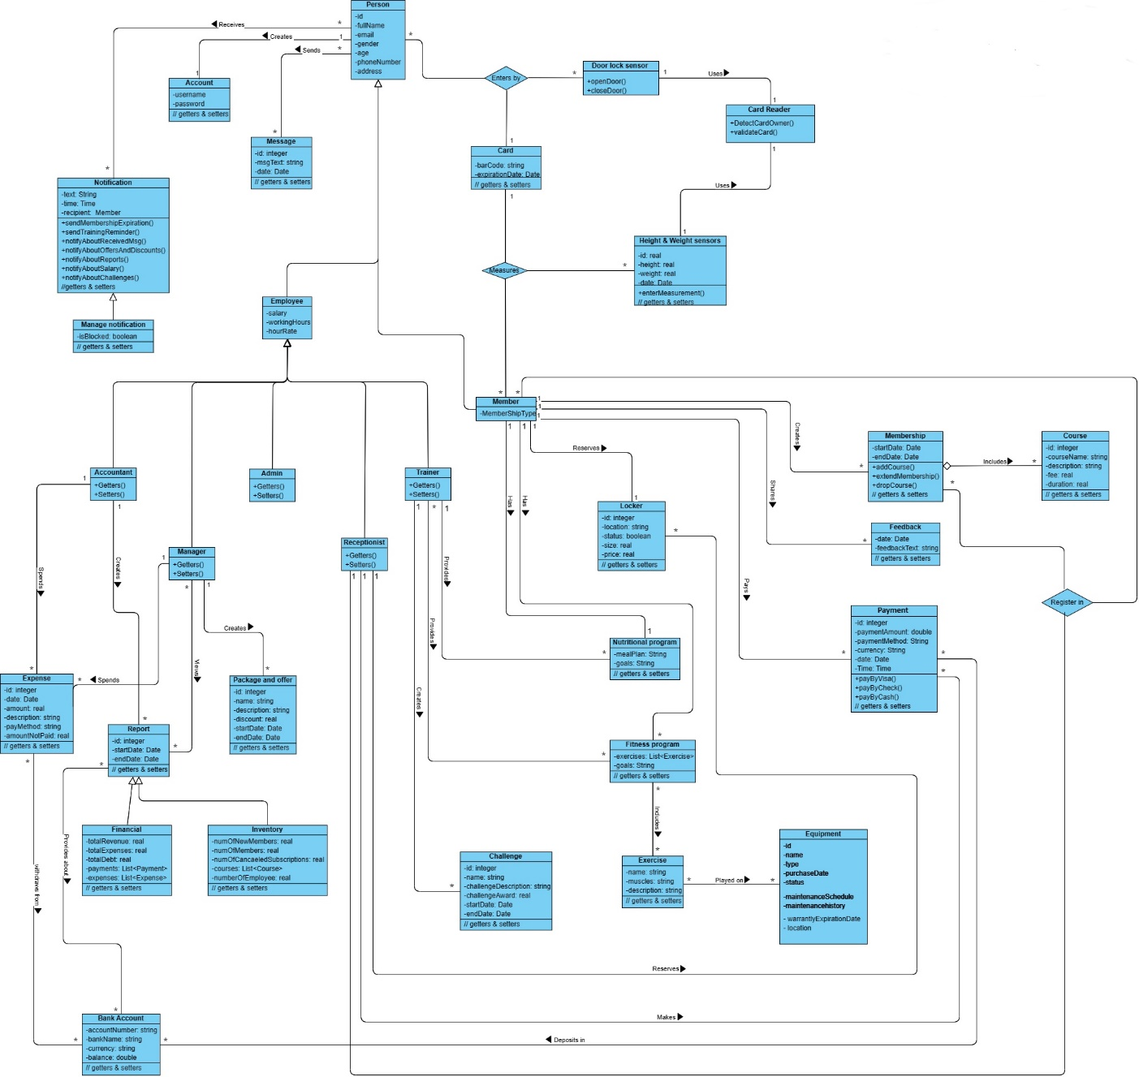

Figure 1: Conceptual class diagram

## **Sequence diagrams**

* 3.1.0. Sequence diagram for UR.1: All users must enter the club through the electronic gates, by placing the club card on the card reader. (Sara Ammar-1191052)

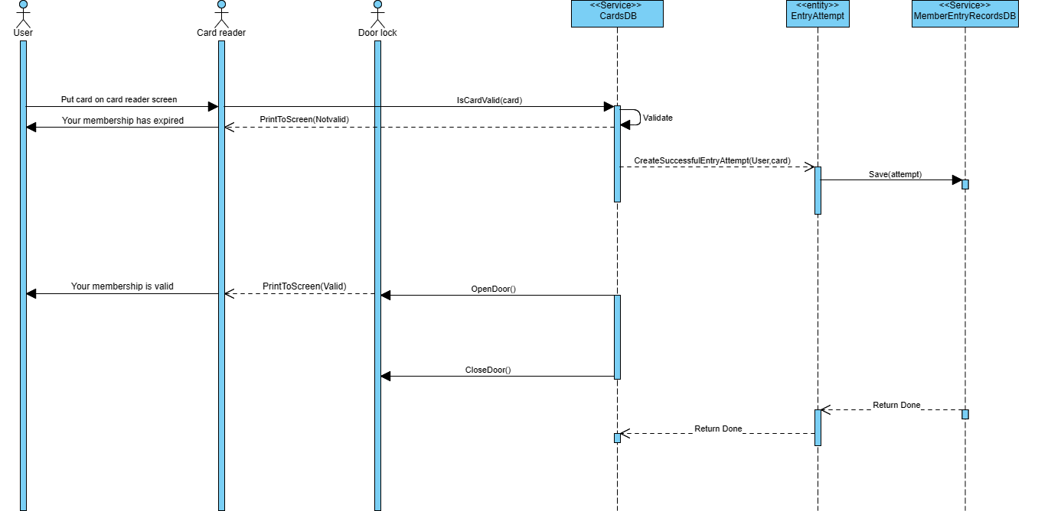

Figure 2: Sequence diagram for UR.1

* 3.1.1. Sequence diagram for UR.4: The accountant shall have access to all financial matters in the club's system, and the ability to make reports on them. (Al Ayham Maree-1191408)

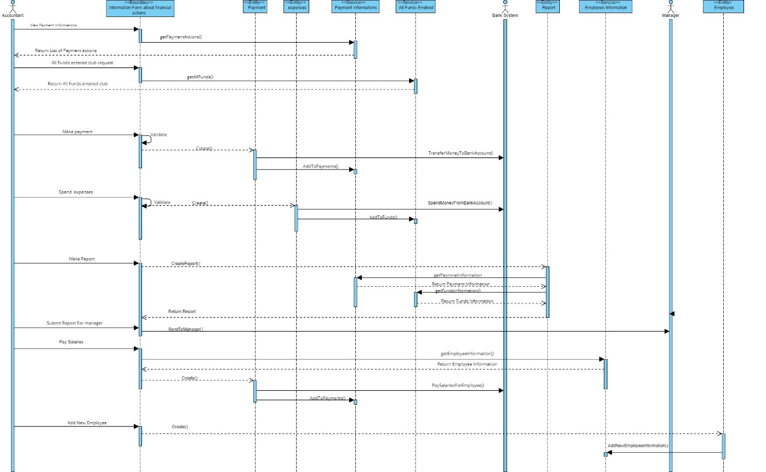

Figure 3: Sequence diagram for UR.4

* 3.1.2. Sequence diagram for UR.7: The system shall enable the users to register a new membership. (Ali Mohammed - 1190502)

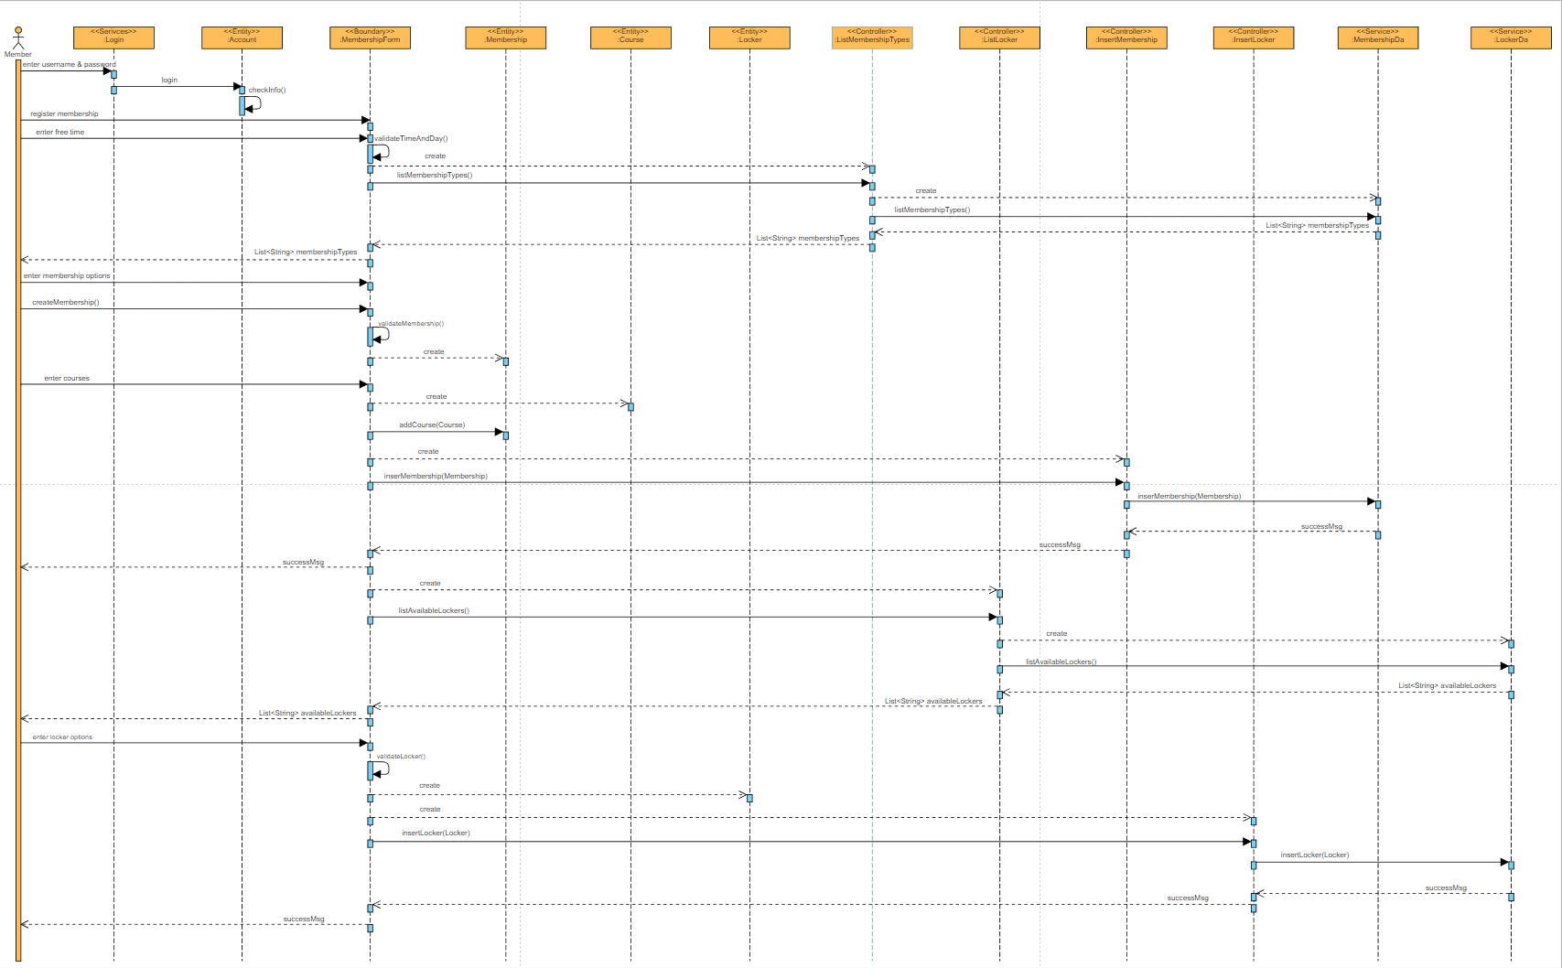

Figure 4: Sequence digram of UR. 7

If it is not visible or clear, you can find it [here](https://online.visual-paradigm.com/share.jsp?id=323333353337332d31) with better resolution.